PF(LAB 5)

1. C Program:

#include <stdio.h>

int main() {

int marks;

printf("Enter marks: ");

scanf("%d", &marks);

if (marks >= 50) {

if (marks >= 85) {

printf("Passed with Distinction\n");

} else {

printf("Just Passed\n");

}

} else {

printf("Failed\n");

}

return 0;

}

OUTPUT

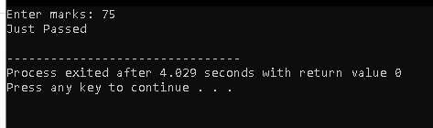

1. C Program:

#include <stdio.h>

int main() {

int age;

char gender;

printf("Enter age: ");

scanf("%d", &age);

printf("Enter gender (m/f): ");

scanf(" %c", &gender);

if (age >= 18) {

if (gender == 'm' || gender == 'M') {

printf("Adult Male\n");

} else if (gender == 'f' || gender == 'F') {

printf("Adult Female\n");

} else {

printf("Invalid gender input\n");

}

} else {

printf("Minor\n");

}

return 0;

}

Output

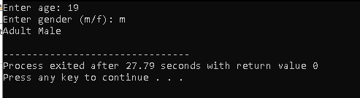

1. C Program

#include <stdio.h>

int main() {

int i, j;

printf("Enter what do you want to select \n1. Mobile \n2. Laptop\n");

scanf("%d", &i);

switch (i) {

case 1: // Mobile

printf("Enter which mobile company you will prefer\n1. Samsung\n2. Apple\n");

scanf("%d", &j);

switch (j) {

case 1:

printf("Samsung smartphones are good\n");

break;

case 2:

printf("Apple smartphones are better\n");

break;

default:

printf("Invalid selection\n");

break;

}

break;

case 2: // Laptop

printf("Enter which laptop company you will prefer\n1. Dell\n2. HP\n");

scanf("%d", &j);

switch (j) {

case 1:

printf("Dell laptops are good\n");

break;

case 2:

printf("HP laptops are better\n");

break;

default:

printf("Invalid selection\n");

break;

}

break;

default:

printf("Invalid selection\n");

break;

}

return 0;

}

Output:

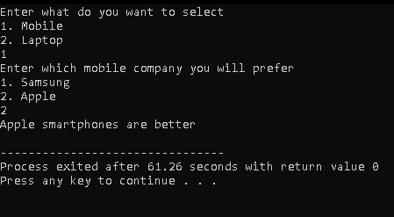

1. C program:

#include <stdio.h>

int main() {

int continent, country;

printf("Select a continent:\n1. Asia\n2. Europe\n");

scanf("%d", &continent);

switch (continent) {

case 1:

printf("Select a country in Asia:\n1. Pakistan\n2. India\n");

scanf("%d", &country);

switch (country) {

case 1:

printf("You selected Pakistan (Asia)\n");

break;

case 2:

printf("You selected India (Asia)\n");

break;

default:

printf("Invalid country selection\n");

break;

}

break;

case 2: // Europe

printf("Select a country in Europe:\n1. France\n2. Germany\n");

scanf("%d", &country);

switch (country) {

case 1:

printf("You selected France (Europe)\n");

break;

case 2:

printf("You selected Germany (Europe)\n");

break;

default:

printf("Invalid country selection\n");

break;

}

break;

default:

printf("Invalid continent selection\n");

break;

}

return 0;

}

Output

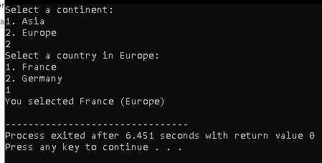

1. C Program

#include <stdio.h>

int main() {

int num;

printf("Enter a number: ");

scanf("%d", &num);

if (num % 2 == 0 && num % 3 == 0) {

printf("%d is divisible by both 2 and 3\n", num);

} else {

printf("%d is NOT divisible by both 2 and 3\n", num);

}

return 0;

}

Output

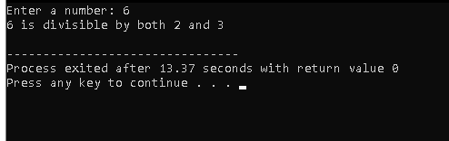

1. C program

#include <stdio.h>

int main() {

int a = 5, b, c;

// Pre-increment example

b = ++a; // first increment, then assign

printf("After pre-increment (++a):\n");

printf("a = %d, b = %d\n\n", a, b);

a = 5; // reset value

// Post-increment example

c = a++; // first assign, then increment

printf("After post-increment (a++):\n");

printf("a = %d, c = %d\n", a, c);

return 0;

}

Explaination

* **Pre-increment (**++a**)**

a is incremented **first** (from 5 → 6).

Then the new value (6) is assigned to b.

Output: a = 6, b = 6.

* **Post-increment (**a++**)**

a is assigned to c **first** (so c = 5).

Then a is incremented (from 5 → 6).

Output: a = 6, c = 5.

1. C Program:

#include <stdio.h>

int main() {

int a, b, c, smallest;

printf("Enter three numbers: ");

scanf("%d %d %d", &a, &b, &c);

smallest = (a < b) ? ((a < c) ? a : c) : ((b < c) ? b : c);

printf("The smallest number is: %d\n", smallest);

return 0;

}

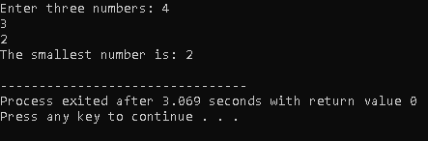

1. C Program

#include <stdio.h>

int main() {

int num, result;

printf("Enter a number: ");

scanf("%d", &num);

// Toggle 2nd bit (bit position 1 -> value 2)

result = num ^ (1 << 1);

printf("Number after toggling 2nd bit: %d\n", result);

return 0;

}

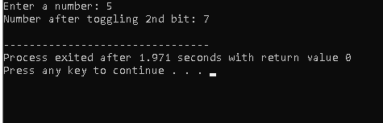

1. C program

#include <stdio.h>

int main() {

int num;

printf("Enter a number: ");

scanf("%d", &num);

if (num & 1) {

printf("%d is Odd\n", num);

} else {

printf("%d is Even\n", num);

}

return 0;

}

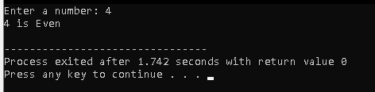

1. #include <stdio.h>

int main() {

int num;

printf("Enter a number: ");

scanf("%d", &num);

printf("Left shift by 1: %d << 1 = %d\n", num, num << 1);

printf("Left shift by 2: %d << 2 = %d\n", num, num << 2);

printf("Right shift by 1: %d >> 1 = %d\n", num, num >> 1);

printf("Right shift by 2: %d >> 2 = %d\n", num, num >> 2);

return 0;

}

